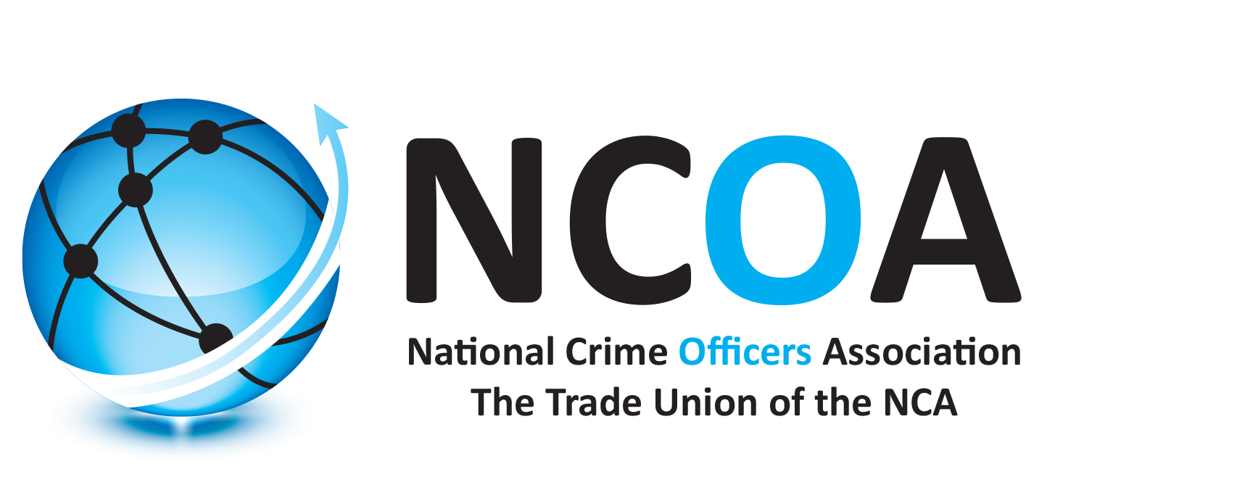
NCOA Ref:

This form is to be completed for all criminal, disciplinary and grievance matters.

Where possible, the NCOA representative should complete this form with the member present. Please provide as much information as possible on this form.

YOUR PERSONAL DETAILS

Title

Forename Surname

Address

Home Telephone Mobile Telephone

Private Email Address

YOUR EMPLOYMENT DETAILS

Staff Number Grade Part Time Worker
*This should be a six digit number beginning with 1 or 2

Work Location

CASE CATEGORY
Please select the type of claim on which advice is sought.
Grievance ☐
Employment Law ☐
Misconduct - Internal Disciplinary ☐
Misconduct/Criminal - IOPC ☐
Criminal ☐
Capability ☐
Post Incident Procedures ☐
If other please specify
DETAILS OF ISSUE
Nature of problem and date(s) it happened (please provide full chronology - continue on additional page as necessary):

Action/outcome sought:

Has anyone else acted on your behalf?
If yes please provide detail:

SUPPORTING DOCUMENTS / INFORMATION CHECKLIST
Please enclose, where possible, the following supporting documents / information, depending on the nature of the assistance required.

Criminal Prosecution Defence
Copy of charge
Details of witnesses
Copy of driving licence and motor insurance policy (for motor prosecution defence claims only)

Employment (including disciplinary matters)
Copy of employment contract
Copy of disciplinary papers and your response
Copy of any letter of investigation
Copies of any other relevant correspondence

IOPC/PONI/PIRC
Copy of any letter of investigation
Copies of any other relevant correspondence

REPRESENTATIVE DETAILS
Name

Telephone Number

NCOA Email Address

I have read and accept the conditions for providing assistance. I confirm that the statement/details above are correct, and I agree to this information being shared with a third party in respect of any action. I understand that data and communications not held on NCOA IT systems may be accessed by third parties - including your employer.

Signature
Date

The Personal Case Form is a confidential document between the member and the NCOA. It is not disclosable in any circumstances - except with the express permission of both the member AND the NCOA.

NCA officers are Civil Servants, bound by Civil service rules and governed by NCA policies & procedures. NCOA Lawyers are therefore not permitted to take part in internal misconduct proceedings.

This form should be completed in consultation with your representative, who will then retain it, and forward a copy to the National Case Coordinator and NCOA appointed lawyers as required - (where relevant criteria have been met).

